**Key:**

Skills from weakest to strongest

**Weak**

**Medium**

**Medium-Strong**

**Strong**

**Section 2 enemies**

**Lucy Mare** (Black-Winged Angel)

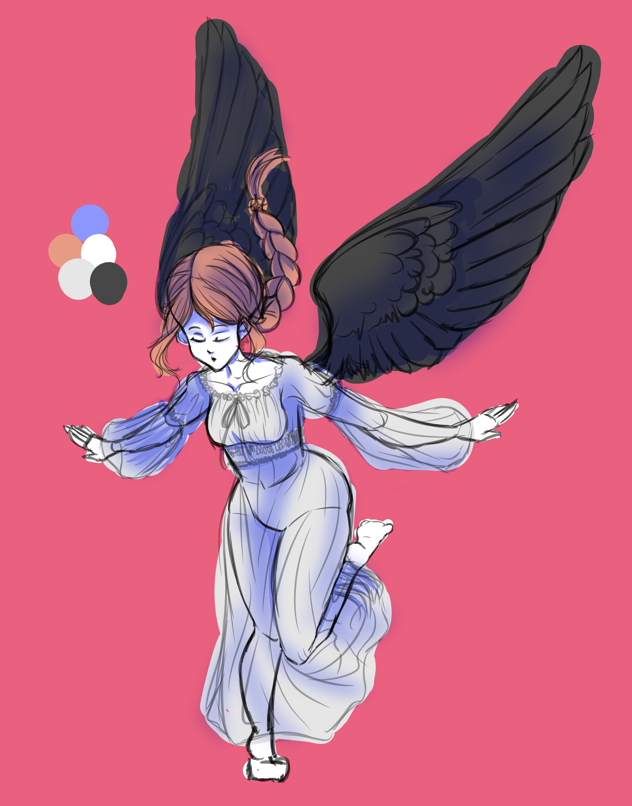

* Description: Lucy comes from Lucifer, the fallen angel. Mare from nightmare. Say it together and pronunciation sounds similar to lucifer too. Female angel in nightgown.
* Combat
  + Skills:
    - **Lullaby** (night music)
    - **Black Eyed** (black eye: “a mark or source of dishonour or shame.” fitting for blacked winged implied fallen angel)
    - **Cipher Night** (another lucifer-nightmare pun, cipher is a hidden code)
    - **Six Step Symphony** (Six -> SSS -> 666. Concept art pose looks like a step)

**Nightwalker** (Succubi)

* Description: Name comes from spirit of the forest in Japanese mythology, translated. Nightwalker also sometimes is related to prostitution. Succubi are demons that prey on people in sexual ways.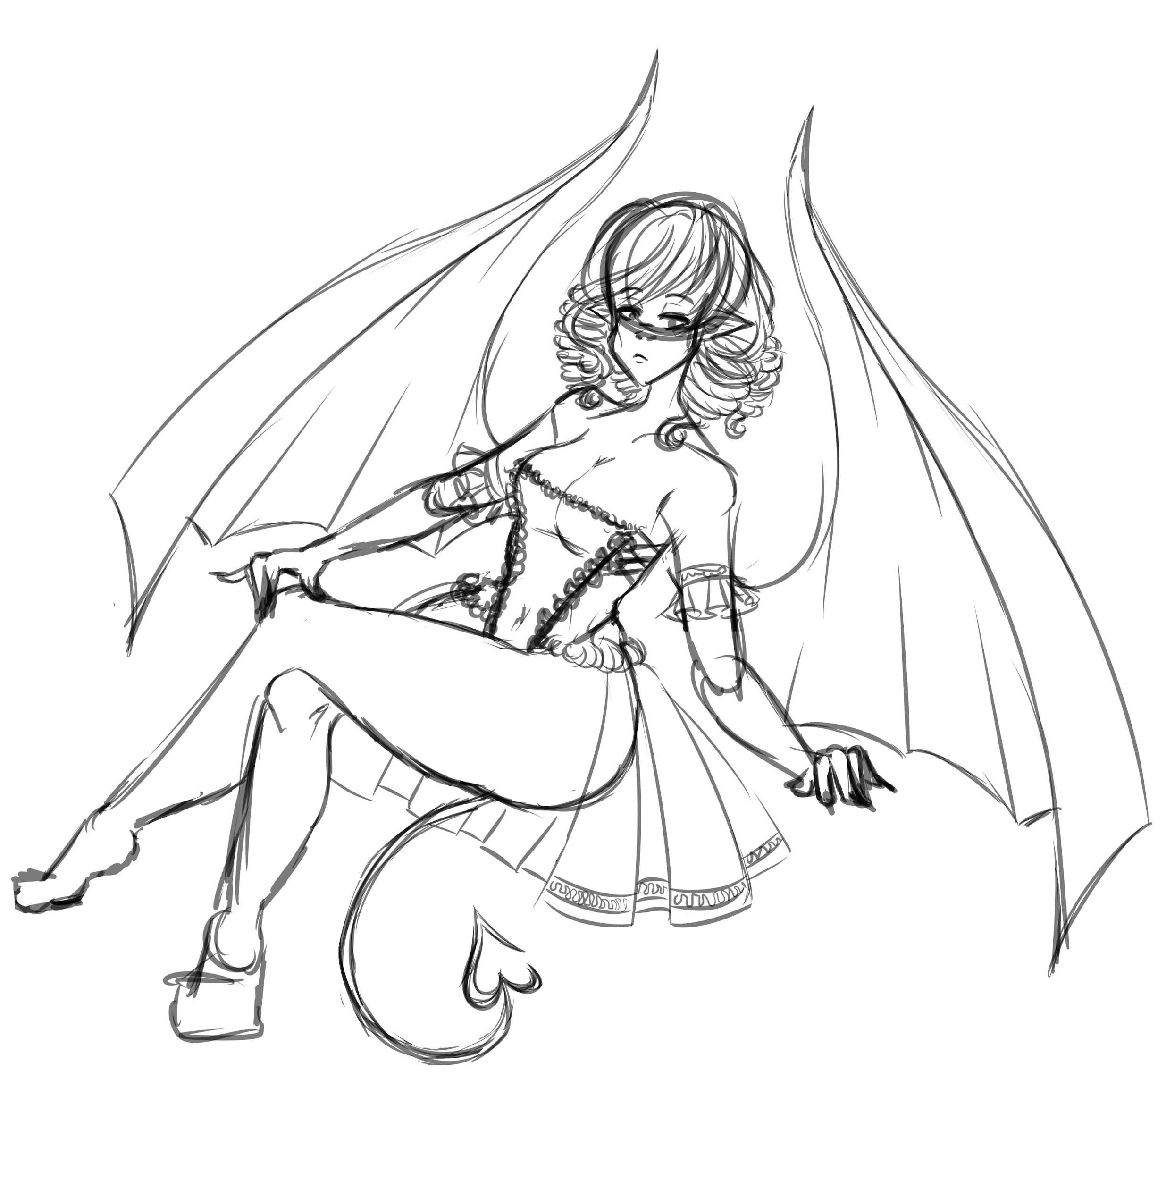
* Combat
  + Skills:
    - **Temptation** (temptation)
    - **Night’s Prelude** (the idea is that the lude bit sounds like lewd, let player find that out)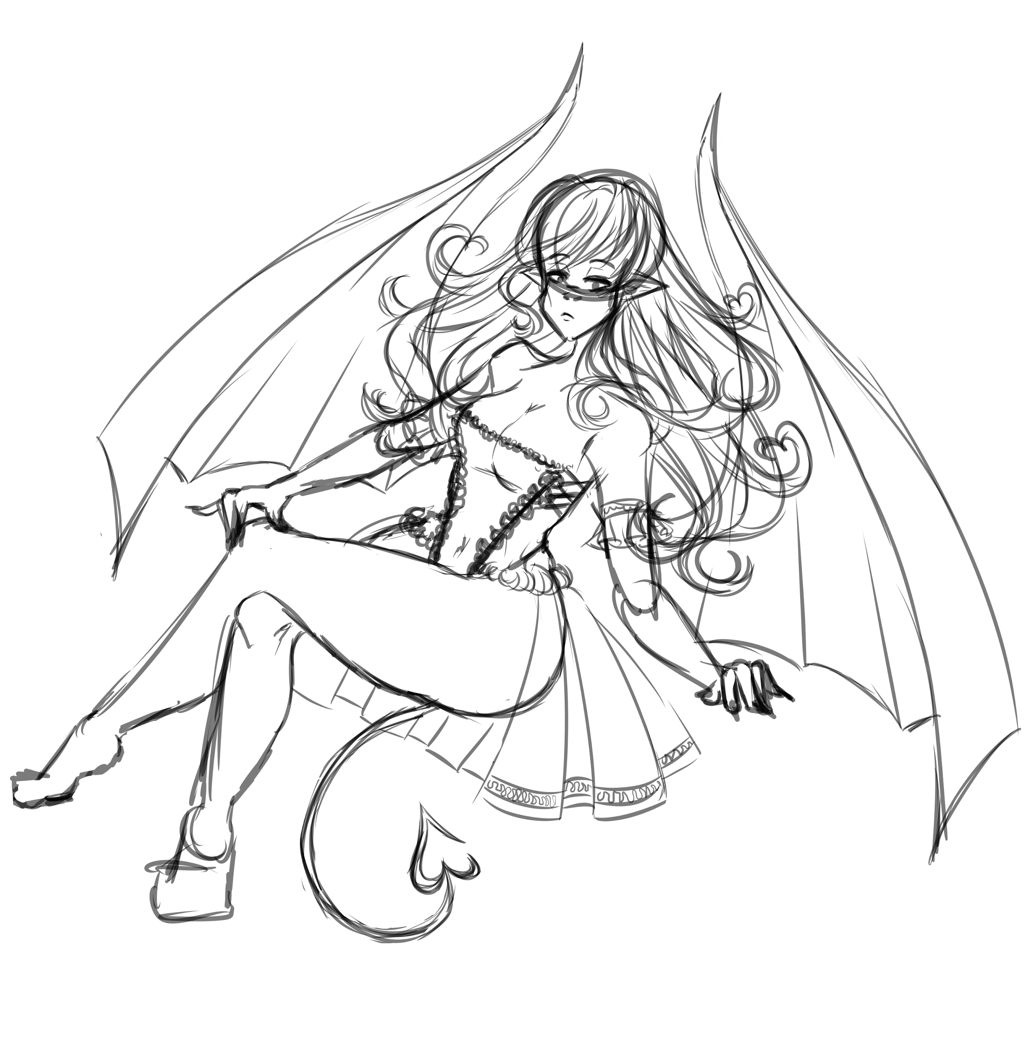
    - **Ars Goetia** (a book that serves as a collection of demons but if you will let’s say ars is arse -> ass right? joke)
    - **Lilith’s Rhapsody** (Lilith: sexual demon of the night. Rhapsody: free flowing music composition)

**Lesulcus** (Winged Demons)

* Description: Anagram of Sucellus, celtic god of forest and alcoholic drinks. A general demon, no specific design in mind.
* Combat
  + Skills:
    - **Taiko-aiko** (Fun name based on taiko drum)
    - **Dion-sus** (From Dionysus, god of wine - “Sus” is also the abbreviation of “suspended chords” in music)
    - **Hyakki Yako** (Japanese yokai term for “the demons’ night parade”)

**Janus Face** (Flying Mask)

* Description: Janus-faced means double-faced. Flying masks that people wear for the masquerade. They appear before the last section because they don’t have an owner. Weakest enemy in area.
* Combat
  + Skills:
    - **Rubato** (music term that means to play with freedom. These masks are free as in no user)
    - **Dance Dance** (basic move name)

**Mask-o-raid** (Flying Masks)

* Description: Various Janus Faces. Masquerade pun.
* Combat
  + Skills:
    - **Rubatoo** (different version of Rubato, spelt ruba-2 because like… second version)
    - **Dance Dance Dance** (different version of Dance Dance)

**Section 3 enemies**

**Aguste Elroux** (Guitar Person)

* Description: Pseudo-anagram of Gaston Leroux, author of the novel Phantom of the Opera. Is a male person wielding a guitar. Elroux pronounced “el-roo”
* Combat
  + Skills:
    - **Four By Four** (4/4)
    - **Pull-me-on** (pull off, guitar technique)
    - **Hammer-me-off** (hammer on, guitar technique)
    - **Tremolo** (guitar technique)
    - **Cadenza Vitale** (sheet music term for solo, basically a guitar solo - vitale means vital, of great importance)

**Yamane** (Spirit Pianist)

* Description: Name based on Michiru Yamane. Classically trained videogame composer + “yama” is a god of death. A female spirit playing piano.
* Combat
  + Skills:
    - **Three By Four** (3/4)
    - **Amadeus** (Mozart)
    - **Pianissimo** (music term, softer than piano)
    - **Aria of Solitude** (reference to Aria of Sorrow, soundtrack by Yamane)
    - **Final Toccata** (Yamane piece of music,also a music term)

**Dolce Virtuoso** (Spirit Music Band)

* Description: Fake band name based on musical terms. Spirit music band
* Combat
  + Skills:
    - **Dee Bee** (decibels aka dB)
    - **Ritmo Andante** (walking tempo)
    - **Prelude in G Minor** (g minor is key of Sebastian theme)
    - **Phantom March** (reference to Turkish March by Beethoven)

**Liedernacht** (Dancing Spirits)

* Description: A couple dancing. Name inspired by Heinrich Heine’s “Buch der Lieder” (“book of songs”) and Schubert’s “Der Doppelgänger” poem. A doppelgänger is a double of a person.
* A lied is an old german term for romantic songs for solo voice. Lieder is the plural of said word. Nacht means night (also german).

*“Oh* [*Doppelgänger*](https://en.wikipedia.org/wiki/Doppelg%C3%A4nger)*! you pale comrade!*

*Why do you mock the pain of my love*

*Which tormented me upon this spot*

*So many a night, so long ago?”*

* Combat
  + Skills:
    - **Figaro** (from the opera "Marriage of Figaro" with music by Mozart)
    - **Valse Vitae** (waltz of life)
    - **Half-Step! Stop!** (half step another musical term)
    - **Dance of Pales** (Reference to pale comrade/companion from the poem)

**Il Decora** (Old Painting)

* Description: Anagram of (Eugène) Delacroix without the X, French romantic era painter. Also sounds like decor(ation)
* Combat
  + Skills:
    - **Claroscuro** (painting technique)
    - **La Croix** (the cross, another reference to the painter)
    - **Dante’s Baroque** (reference to Delacroix’s “The Barque of Dante”. Baroque is a time period relevant to area style in a way)

**Hollowbody** (Spirit Instruments)

* Description: Simpler name. Instruments are hollow body ones. A group of violin, viola, cello.
* Combat
  + Skills:
    - **Legato-Sustain** (two playing techniques, common with string instruments)
    - **Whole Lotta Sound** (These instruments have sound holes -> sound whole -> whole sound -> we take Led Zepellin song Whole Lotta Love -> Whole Lotta Sound)
    - **Spirit Ensemble** (they are an ensemble, they are spirits)

**Fullrest** (Spirit Tables with Candles)

* Description: Another smaller enemy. Name based on whole rest a term in music that means complete pause, no sound.
* Combat
  + Skills:
    - **Espressivo** (An instruction meaning that a passage should be played expressively)
    - **Innocent Harmony** (The table and candle go well together,,, harmony… music...)
    - **Silent Elegy** (Rest related enemy. Elegy is a lamentful piece of music)